# Land cover land use Methodology

The procedure followed by supervised classification is categorizing all pixels in a digital image into different land use / land cover classes. Depending on the interaction between computer and interpreter during classification process. This classification process involves conversion of multi-band raster imagery into a single-band raster with a number of categorical classes that relate to different types of land cover. Using this method, an image is classified using spectral signatures (i.e., reflectance values) obtained from training samples (polygons that represent distinct sample areas of the different land cover types to be classified) as seen in the following figure.

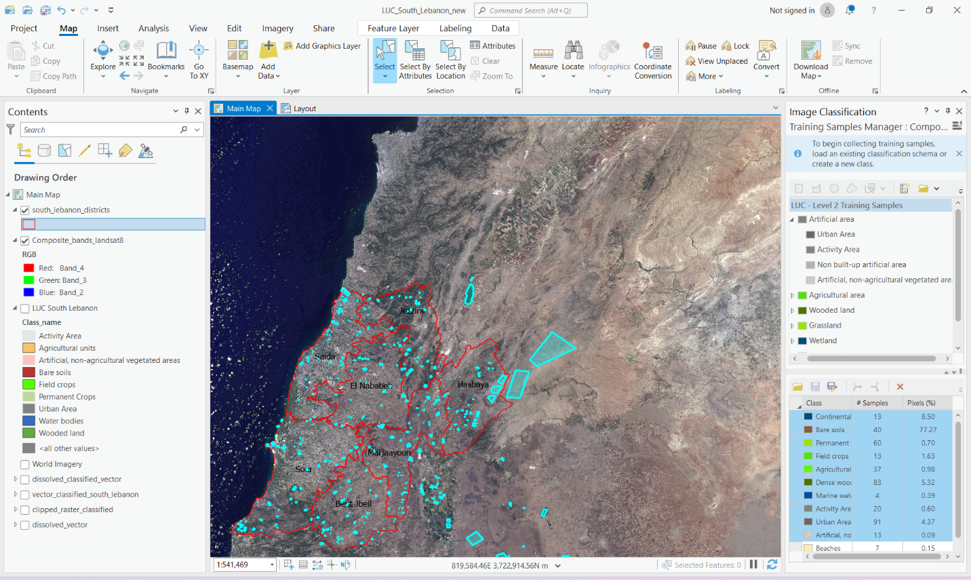

Figure 1: Training Samples of the supervised classification

To start with Landsat 8 TM image 2024 - bands (band 1 to band 7) were added to the ArcGIS Pro software and a composite image was created using composite bands tool. Next step was adding the area of interest (AOI) which belong to Governorate South Lebanon (see Figure 2 ) and training samples are then captured using different band combinations (see figure 1). Later on, after the training samples were collected, classificatin image was created using interactive supervised classification. The classified AOI image has been extracted using clip raster tool and then transformed into vector format using “Raster to Polygon” tool in order to know the area for each class.

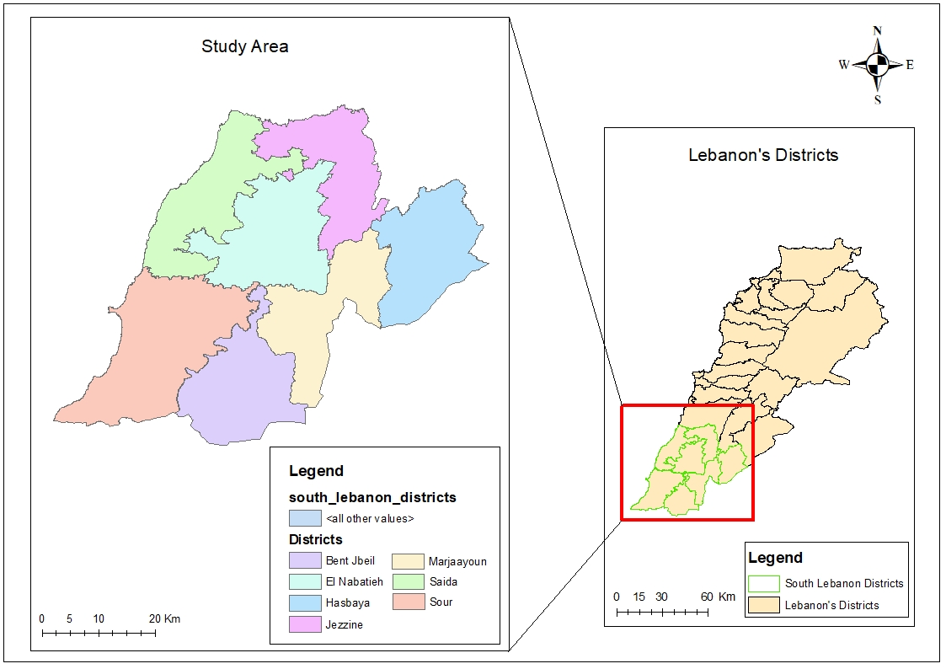

Figure 2: Study Area of South Lebanon

Finally, the LUC image for south Lebanon 2024 was created for the study area (see figure 3) and the areas were measured and calculated for all the assigned classes and then extracted in order to be used for comparison and delivering the end results needed.

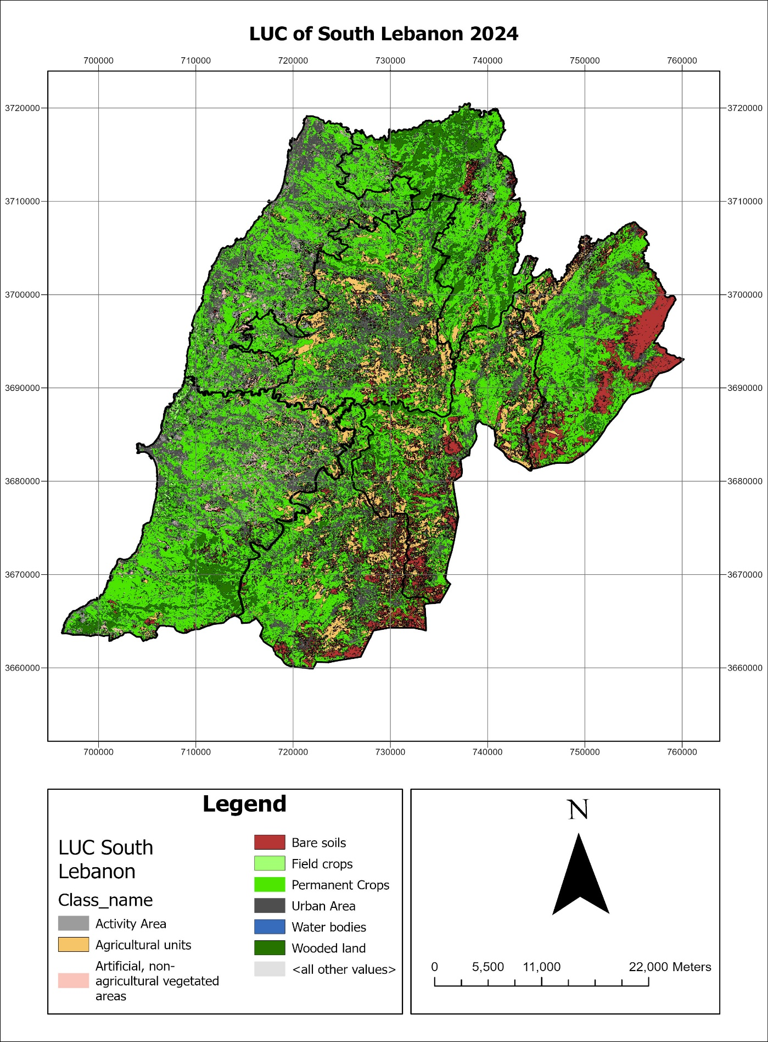

Figure 3: LUC of South Lebanon 2024